Doc 03 Scrum in Agile

## Scrum Definition

Scrum is a framework within which people can address complex adaptive problems, while productively and creatively delivering products of the highest possible value.

Scrum is a process framework that has been used to manage complex product development since the early 1990s. Scrum is not a process or a technique for building products; rather, it is a framework within which you can employ various processes and techniques. Scrum makes clear the relative efficacy of your product management and development practices so that you can improve.

The Scrum framework consists of Scrum Teams and their associated roles, events, artifacts, and rules. Each component within the framework serves a specific purpose and is essential to Scrums success and usage.

The rules of Scrum bind together the events, roles, and artifacts, governing the relationships and interaction between them. The rules of Scrum are described throughout this tutorial.

**Note** - Across the industry, there are misconceptions that Scrum means no documentation, scrum team consists of only developers, and so on. It is not entirely so;

## Scrum Process Framework

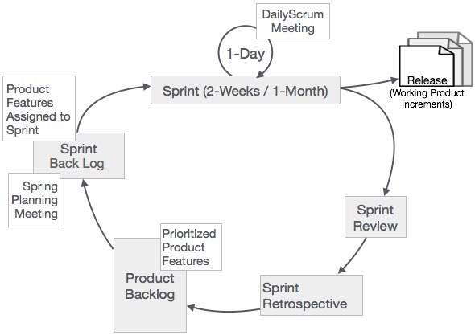

In Scrum, the prescribed events are used to create regularity. All events are time-boxed events, such that every event has a maximum duration. The events are described more elaborately in the subsequent chapters.